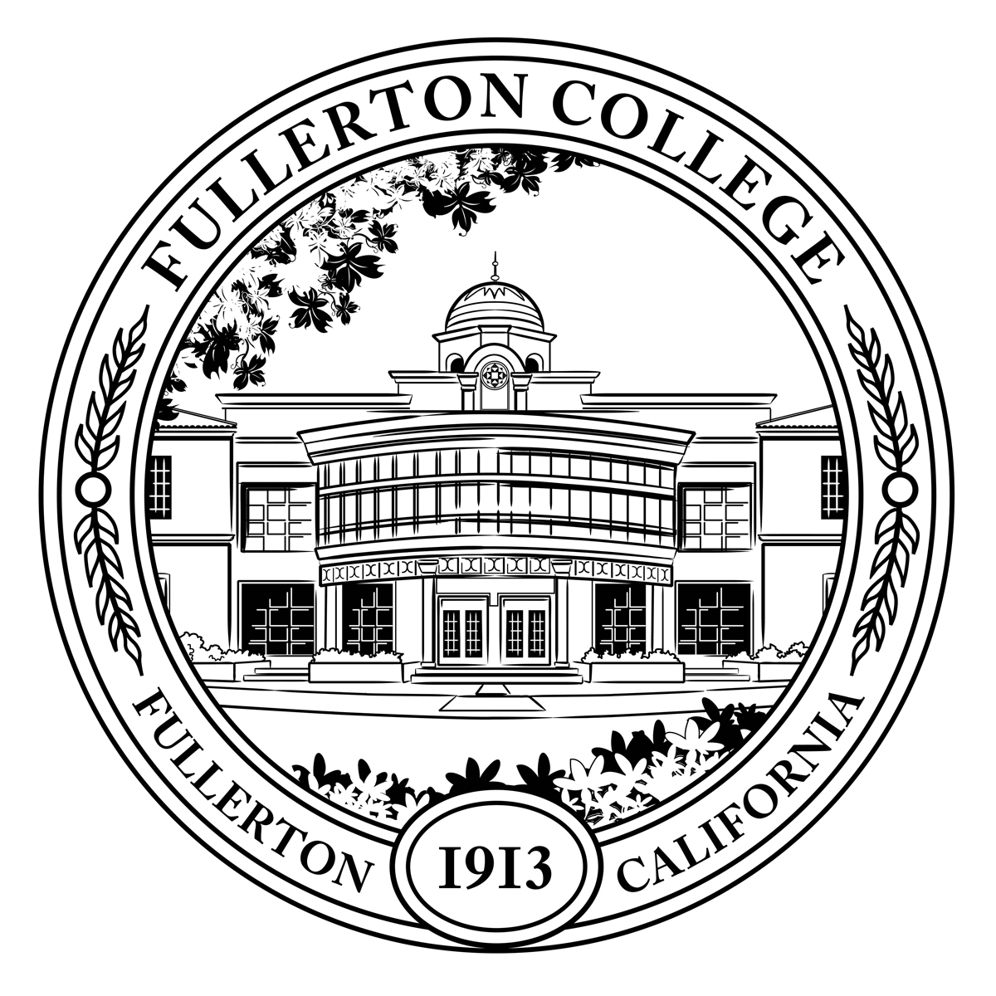
Pathways Steering Committee
Meeting Minutes

Co-Chairs: Matt Taylor (F), Jennifer Merchant (M)
Voting Members: Brandon Floerke (F), Miguel Powers (F), Jeanne Costello (F), Kim Vandervort (F), Alexandria Rosales (F), Arnette Edwards (F), Linda Kelly-Mandich (F), Gregory Menchaca (C), Dani Wilson (M), Ericka Adakai (M), Connie Moreno Yamashiro (M), Rolando Sanabria (F)
Resource Members: Deniz Fierro (M), Kim Vandervort (F), Kyle Stroud (C), Jeanne Costello (F), Jorge Gamboa (M), Cynthia Guardado (F), Stephanie Nguyen-Preciado (C), Albert Abutin (M), Rena Martinez-Stluka (M), Megan Harris (C)
Guests: Dr. Monte Perez, Flor Huerta, Antonio Ramirez, Khaoi Mady
Recorder: Bianca Gladen (C)

Members Absent: Rolando Sanabria (F), Jennifer Merchant (M), Brandon Floerke (F), Cynthia Guardado (F)

C = Classified; F = Faculty, M = Manager, S = Student

Meeting time of order: 1:05pm

- Welcome
  - Welcomed the new Guided Pathways Director, Jennifer Merchant who will officially start November 1st, 2022.
  - Welcomed newly elected counseling representative, Rolando Sanabria.

- Approval of September 12th Meeting Minutes

- PSC Community Agreement
  - Committee voted to delay discussion on this topic until the next meeting in November when the new Guided Pathways Director, Jennifer Merchant officially starts.

- SEA 2.0--Braiding Student Equity and GP (refer to Breakout Activity attachment)
  - The committee had a breakout room activity to share ideas and thoughts how SEA 2.0 and Guided Pathways goals can intersect and braid efforts with one another.
  - An idea shared by Arnette Edwards and members of that breakout group thought SEA 2.0 goals #1-7 could be braided with the frequency of counseling appointments and consistency with students. If students are consistent with seeing a counselor and having the right educational plan in place, they are more likely to complete their goals, degrees, and certificates. Students connecting with specialty programs (for example Umoja and Puente) can have that sense of community for those disproportionate student groups.
  - Alexandria Rosales shared the idea that we should use the same approach that we have been using in programs, such as EOPS, in providing consistent access to counselors, ongoing updated comprehensive educational plans. Once we have Starfish updated, we would have transcripts uploaded in place with their audits and other college transcripts.
  - Kim Vandervort, Linda Kelly-Mandich, Kyle Stroud, Jorge Gamboa, and Khaoi Mady suggested that Outreach, Promise, and FYE can help increase the number of students that successfully enroll at Fullerton College by creating onboarding/welcome experiences that establish purpose and belonging, and guide students from acceptance to successful enrollment supported by Guided Pathways. This group also suggested that “Decreasing the disproportional impact in the retention of Black/African American students between their first primary and second primary term of enrollment” could be aided through student services (educational planning, transfer center, counseling center) and strengthened by Guided Pathways. FYE can also create more intentional connections between student services and students. SEA 2.0 goals #5-7 can be supported by 2nd/3rd Year Experience as well as Guided Exit.
  - Flor Huerta, Jeanne Costello, Greg Menchaca, Deniz Fierro, and Dani Wilson’s group collaborated on intersecting SEA goals with Guided Pathway goals.
    - They thought SEA 2.0 goal #1 and GP goal A could intersect in the New Class Schedule & Registration by developing the ability to successfully register new students earlier in the onboarding process. FYE- providing wrap around, high-touch support services and case management for Black/ African American and Latinx students. Program Mapping. Real Time Degree Audit- Ensuring students and support professionals have access to accurate information (OTC’s, AP units, Degree/Program, etc.)
    - SEA 2.0 goal #2 and GP goal E could intersect with IST, by helping faculty better connect career and educational program for Black/African American students in all classes; Help faculty create equitable pedagogy; Help faculty learn how to talk about race in their classrooms. Starfish Early Alert (Increased use of early alert to help support Black/African and Latinx students academically before they drop out. Starfish Student Success Network and case management. FYE (Provide wrap around, high-touch support services and case management for Black/African American and Latinx students. Program Mapping.
    - SEA 2.0 goal #3 and GP goals C & D. IST - Help faculty better connect career and educational program for Black/African American students in all classes; Help faculty create equitable pedagogy; Help faculty learn how to talk about race in their classrooms. Real Time Degree Audit (Ensuring that students and support professionals have access to accurate information [OTCs, AP units, Degree/Program, etc.] and Program Mapping.
    - SEA 2.0 goal #4 and GP goals C&D. IST -Help faculty better connect career and educational program for Black/African American students in all classes; Help faculty create equitable pedagogy; Help faculty learn how to talk about race in their classrooms. FYE -provide wrap around, high-touch support services and case management for Black/African American and Latinx students. Starfish Early Alert (Increased use of early alert to help support Black/African American and Latinx students academically before they drop out. Starfish Student Success Network and case management (Provide wrap around, high-touch support services and case management for Black/African American and Latinx students. Real Time Degree Audit (Ensuring that students and support professionals have access to accurate information [OTCs, AP units, Degree/Program, etc.
    - SEA goal #5 and GP goals B, C,&E. IST -Help faculty better connect career and educational program for Black/African American students in all classes; Help faculty create equitable pedagogy; Help faculty learn how to talk about race in their classrooms. Starfish Early Alert (Increased use of early alert to help support Black/African American and Latinx students academically before they drop out. Starfish Student Success Network and case management (Provide wrap around, high-touch support services and case management for Black/African American and Latinx students. FYE -provide wrap around, high-touch support services and case management for Black/African American and Latinx students. 2nd/3rd Year Experience--Guided Exit (Provide clear academic, transfer, and career pathways for Black/African American and Latinx students. Program Mapping and Real Time Degree Audit.
    - SEA 2.0 goal #6 and GP goal F. 2nd/3rd Year Experience--Guided Exit (Provide clear academic, transfer, and career pathways for Black/African American and Latinx students. Starfish Early Alert (Increased use of early alert to help support Black/African American and Latinx students academically before they drop out. Starfish Student Success Network and case management (Provide wrap around, high-touch support services and case management for Black/African American and Latinx students. FYE -Provide wrap around, high-touch support services and case management for Black/African American and Latinx students. 2nd/3rd Year Experience--Guided Exit and Real Time Degree Audit.
    - SEA 2.0 goal #7 and GP goal F. -Starfish Early Alert (Increased use of early alert to help support Black/African American and Latinx students academically before they drop out. Starfish Student Success Network and case management (Provide wrap around, high-touch support services and case management for Black/African American and Latinx students. -FYE (Provide wrap around, high-touch support services and case management for Black/African American and Latinx students. 2nd/3rd Year Experience--Guided Exit (Provide clear academic, transfer, and career pathways for Black/African American and Latinx students. Program Mapping and Real Time Degree Audit.
  - Miguel Powers, Stephanie Nguyen-Preciado, Rena Martinez-Stluka and Megan Harris’ group collaborated and thought IST (Math/English transfer) could decrease the disproportional impact related to Black/African American students that successfully complete transfer level Math and English in their first two semesters by division specific curriculum and pedagogy strategies to support Black/African American and Latinx students – support faculty in implementing these strategies. Intentional, race focused approach- not just a rising tide raising all boats. Program Map from completion to transfer. FYE- retention and enrollment, and CTE – counseling support (degree vs certificate). Professional learning- reframing Prof Learning to offer more sustained learning (as suggested in the report) we also need to create more faculty engagement-how to get those who have not been engaged to engage in the new model? Offering new models without new engagement/motivation for faculty and staff will not broaden the appeal.

- Project Updates
  - FYE Updates
    - FYE is partnering with Promise and Outreach for Future Hornet Day (START) event on Dec. 15. New Student Welcome Day which is in collaboration with Hornets Tutoring on Jan,18. FYE is working on their Embedded Experiences Spring Pilot, which is working toward incorporating engagements into students first year courses, specifically English, Math and Comm studies. FYE is also making progress on the badging and incentives portion of the program (finalizing initial badging pathways for Spring 2023).

  - SENSE Survey
    - Finished administering the survey end of September 2022. The SENSE survey was administered in-person and online to approximately 45 classes. The survey was also given to 800 students who were first-time students and only enrolled in online courses (about 40 students responded). In addition to the standard survey, a supplemental questionnaire regarding student transfer was given out with the surveys this year. Survey results should be in around late Spring/early Summer.
    - Guided Pathways counseling survey is OIE’s next survey. The counseling team had a work group to help develop this survey last year and is aimed to start October 24th campus wide. OIE is looking for volunteers to test and validate the survey links.
  - Program Mapping Advisory Taskforce (PMAT)
    - PMAT had their first meeting in September, with the next one being on October 24th, 2022. One of the taskforce’s goals will be finishing the remaining 25-30 pending maps by the end of Fall, which will total to about 100 of Fullerton College’s programs being published online.
  - Starfish
    - Faculty members received a progress survey where they were encouraged to send a Kudo to students, as well as invite students to their office hours. A few hundred kudos have been sent out and faculty are using the tool. Promise is continuing to use Starfish to case manage the Promise cohort Fall 2022.

- Pathways to Success—Flor Huerta
  - Objectives:
    - Promote student engagement through program/ service student participation
    - Connect students to career and counseling resources that support both personal and academic goals
    - Support and contribute to Fullerton college, Guided Pathways and Equity goals and
    - Build community, elevate student voices and experiences
  - Explore -Fall 2022: First Gen Campaign. Career Exploration. Transfer and Career Education.
  - Declare -Spring 2023: Major Declaration Day (3/14/23) and Counseling Appointments
  - Graduate -Summer 2023: Counseling student follow-up
  - First-Gen Fridays will be used to highlight campus community, counseling student re-engagement and appointments, and completion efforts.
  - Open House- week of November 7-10, 2022 will have student panels and webinars, counseling services, and career activities.

Meeting adjourned at 2:32pm.

To-Do Next Meeting:
  - Follow up on the work activity of braiding SEA 2.0 goals with Guided Pathways goals
  - Community Agreement

NEXT MEETING: Monday, November 14, 2022 @ 1pm

