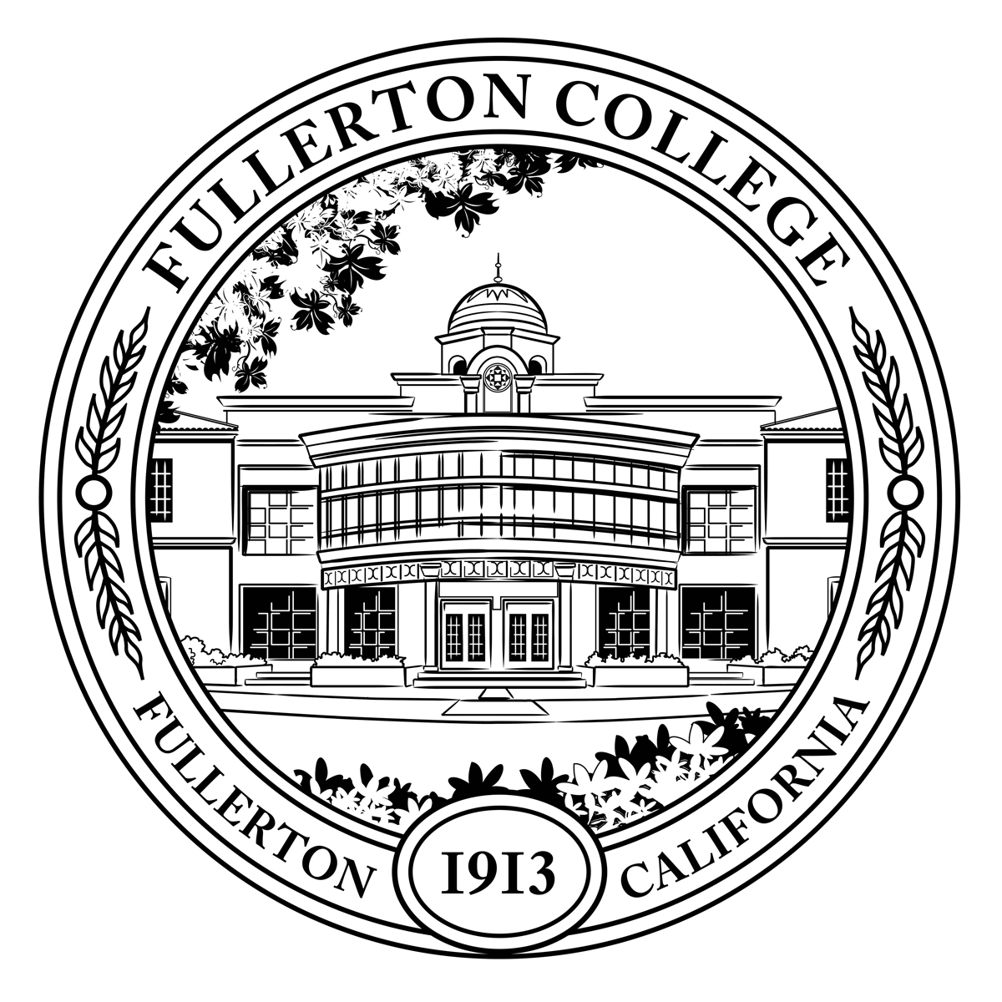
Pathways Steering Committee
Meeting Minutes

Co-Chairs: Matt Taylor (F), Jennifer Merchant (M)
Voting Members: Miguel Powers (F), Kim Vandervort (F), Alexandria Rosales (F), Arnette Edwards (F), Linda Kelly-Mandich (F), Dani Wilson (M), Ericka Adakai (M), Connie Moreno Yamashiro (M), Rolando Sanabria (F)
Resource Members: Deniz Fierro (M), Kim Vandervort (F), Kyle Stroud (C), Stephanie Nguyen-Preciado (C), Albert Abutin (M), Rena Martinez-Stluka (M), Megan Harris (C), Daniel Berumen (M)
Guests: Flor Huerta, Antonio Ramirez,
Recorder: Bianca Gladen (C)

Members Absent: Brandon Floerke (F), Jeanne Costello (F), Gregory Menchaca (C), Jorge Gamboa (M), Cynthia Guardado (F)
C = Classified; F = Faculty, M = Manager, S = Student

Meeting time of order: 1:05pm

- Welcome

- Approval of September and October Meeting Minutes

- PSC Community Agreement

- PMAT Proposal: Allowing recommended classes in major prep

  - The program mapper software now allows for a Major required course or Restricted Electives to be recommended by faculty.
  - PMAT has voted to change the design principles to allow this feature.
  - Linda Kelly-Mandich made a comment that the navigation of Program Mapper should be explained to students and not assumed they would know how to use the maps and click on the tiles.
  - Rena Martinez-Stluka wanted to know if Program Mapper is planning to build pre-requisites into the maps. Guided Pathways is planning to reach out to the curriculum committee to discuss this topic and will update the PSC at the next meeting.
  - PSC committee has voted to approve the Recommended Course feature.

- New Proposed Class Schedule and Registration Calendar
  - Guided Pathways is meeting with NOCCCD, Cypress and Fullerton on November 21st to discuss the new proposed class schedule and registration calendar
  - The committee has been sent the proposal and the narrative of the project
  - Dr. Li-Bugg will be taking the proposal to the Chancellor
  - Linda Kelly-Mandich commented that special programs and the way they recruit will have the most impact, ie: Puente, STEM, SLC. These programs will need more support in recruiting by the campus

- Enrollment and Re-Engagement Proposal Update (Daniel)

  - Daniel presented the Enrollment and Re-Engagement Proposal to the committee and is looking for feedback to provide to PBSC
  - Rolando has a concern with the proposal stating that the support is to hire high school counselors. It does not list the hiring process and contractual rights that are associated with that. There is a need for more money, but the idea of high school counselors without going through the process was a concern of the counseling department.
  - Kim shared that FYE is part of the proposal as well as Mindful Growth. Kim wants to continue to advocate for funding for these programs.
  - Miguel wondered why mental health funds were under Outreach

- Institutional Integrity Committee (IIC) and Office of Institutional Effectiveness (OIE) update

  - IIC and OIE have been working together to update the college Mission and Values as well as a draft set of goals and objectives that are tied with the new mission and core values
  - The next steps for approval of the Mission and Values is Nov. 15 discussion at Associated Students, Nov. 30th second read and vote at PAC and the NOCCCD board approval is TBA
  - Daniel’s link to the 2023-2025 Collegewide Strategic Goals and Objectives Forum is posted below
  - https://bit.ly/FCGoalsForum22

- Student Focus Group Update (Miguel Powers)
  - The Student Focus Group goal is for students to feel accepted, valued, included and encouraged. The goal of this project is to learn what Fullerton College can do to support student’s sense of belonging.
  - Students of color felt less of belonging and sense of community at Fullerton College and this focus group tries to answer “why”.
  - Theme 1 from the survey inquiry group, “Becoming an Anti-Racist College”. The general observation was that students of color experience college and the campus differently from white students. Evidence suggests that students of color feel less comfortable in shared spaces on campus and in the classroom.
  - Theme 3: Strengthening the Student Experience through the Classroom. The general observation was that students at Fullerton College report lower rates of engagement with classmates and professors in and out of class.
  - Phase 1 of the Focus Group: Recruited students from 21 SENSE classes and 33+ students participated in the focus group
  - Some remarks students have suggested were:
    - Having teachers create more opportunities for students to collaborate during class
    - Promote more communication among students
    - Creating more visible opportunities for students to bond in class, club settings and other out of class events
    - Make sure professors are open-minded and supportive of people of all demographics
    - Having professors hear student experiences can influence how to teach
    - Including more ethnic backgrounds, each ethnicity has their own celebration on different things
  - The next step of the Focus Group is to reach out to the campus and review student responses, identify needs, and work towards solutions
  - Reach out to Stewart to use Mongoose, a texting software to reach out to students who did not respond to emails
  - This is an annual project of student focus groups that will be funded. We will be developing a proposal for year 2 to develop more focus groups for Fall.

- Program Review
  - Matt, Bianca, and Jenn are completing the Program Review for Guided Pathways and would like input and feedback from the Pathways Steering committee on the Mission, Vision and Core Values
  - Most of the committee preferred Version B of the Mission Statement.
    - Albert mentioned to use the word “initiatives” instead of structures
    - Greg mentioned if the Mission can use text that includes alignment with the CCCCO’s Vision for Success
    - Connie gave some feedback for the Mission: “The entire student journey - can that instead be: their educational journey and (2) marginalized groups of students - instead marginalized student communities”

- Updates:
  - Matt said he can email the committee on updates on the list below since we were not able to go over them due to limited time.
  - Starfish
  - IST (Instructional Success Teams)
  - FYE (First Year Experience)
  - Real Time Degree Audit
  - Counseling Survey
  - ZTC Grant (Zero Cost Textbook)

- Ask for Volunteers to Support:
  - Starfish Early Alert
  - Automatic Alerts
  - ZTC Work Group
  - FYE
    - Asking for volunteers for advisory workgroup,
    - Matt will email that out and include all the folks that worked on GP and FYE in the past
    - Their first formal event is in December

- Next Meeting: February 13, 2023
- Future Topics:
  - Program Pre-requisites and the outcome of the curriculum committee
  - Approval of the meeting minutes
  - Matt- email updates to PSC we were not able to get to
- Starfish
- IST (Instructional Success Teams)
- FYE (First Year Experience)
- Real Time Degree Audit
- Counseling Survey
- ZTC Grant (Zero Cost Textbook)

