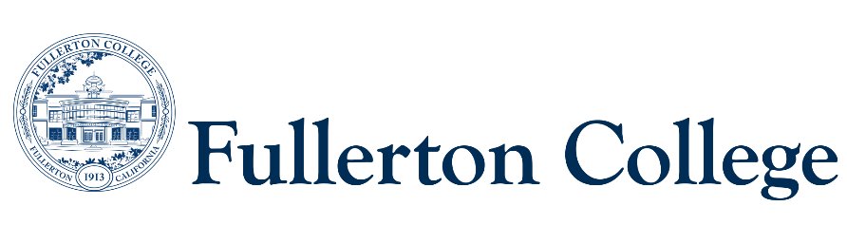

**Program Mapping Advisory Taskforce Agenda**

November 28, 2022 (1pm-3pm)

Zoom:

<https://fullcoll-edu.zoom.us/j/99503824590?pwd=Z0NCZUZiL2t6dGFjdVA2VE5HZkcyUT09>

1. Welcome
2. Approval of Previous Meeting Notes (Sep & Oct)
3. Discussion: Approval of Assigned Pathways
4. Discussion: Creating Milestones for Degrees/Certificates
5. Future Topics:

Next Meeting: Monday, January 23rd (1pm-3pm) ??