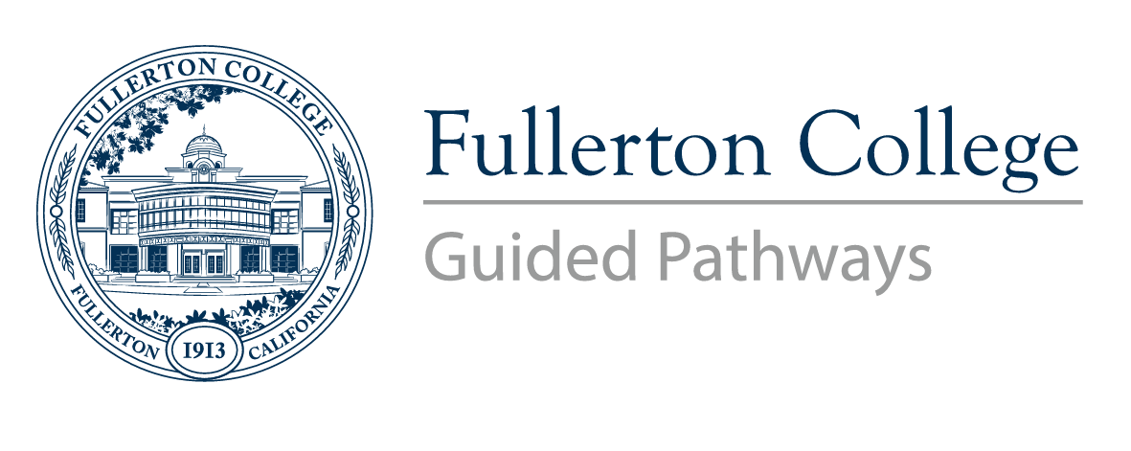
Pathways Steering Committee
Meeting Minutes

Co-Chairs: Matt Taylor (F), Jennifer Merchant (M)
Voting Members: Miguel Powers (F), Kim Vandervort (F), Alexandria Rosales (F), Arnette Edwards (F), Linda Kelly-Mandich (F), Dani Wilson (M), Ericka Adakai (M), Connie Moreno Yamashiro (M), Rolando Sanabria (F)
Resource Members: Deniz Fierro (M), Kim Vandervort (F), Kyle Stroud (C), Stephanie Nguyen-Preciado (C), Albert Abutin (M), Rena Martinez-Stluka (M), Megan Harris (C), Daniel Berumen (M), Gregory Menchaca (C), Jeanne Costello (F)

Guests: Antonio Ramirez, Dr. Cynthia Olivo, Khaoi Mady
Recorder: Bianca Gladen (C)

Members Absent: Brandon Floerke (F), Jorge Gamboa (M), Cynthia Guardado (F), Dani Wilson (M), Albert Abutin (M)
C = Classified; F = Faculty, M = Manager, S = Student

Meeting time of order: 1:01pm
- Welcome and Introductions
- Announcements
  - Antonio Ramirez announced that the Guided Pathways workplan is out and in NOVA and due June 1, 2023.
  - Campus Collaboration team has been approved.

- President Dr. Olivo
  - Dr. Olivo raised the question, “how does our campus use Program Mapper maps?”
  - How do faculty, students and staff use maps? How can we utilize those maps to make it easier for students to register?

- Approval of November 2022 meeting notes
  - Miguel and Arnette motioned to approve November 2022 minutes.

- GP Office Updates
- The GP Office program review has been completed and submitted. A copy is available for the PSC at FINAL 22-23 Program Review - Guided Pathways 1.21.23.pdf
- ZTC, LTC, and textbook adoption: GP Office is leading a collaborative effort to redesign textbook adoption to ensure that all students know the cost of their textbooks before they register for a class.
- Guided Pathways has put together a Textbook Adoption workgroup and currently putting together semester meetings.
- ePortfolio Pilot Project
  - Using Portfolium as a pilot and created an assignment on Canvas for ePortfolio and recorded the session.
- PSC Workgroups
  - We are calling on members in this committee to support some workgroups. A PSC workgroup sign-up form will go out later this week.

- FYE Update
- FYE had their New Student Welcome Day and served 129 students
- Kyle and Kim have attended an FYE national conference to learn about other community colleges using FYE.
- Faculty pilot started, faculty members were chosen from COMM, ENG, and MATH courses and are piloting the key area engagements in their classes
- FYE is moving forward towards Badging. The badges are in the process of being designed. Around early March they are expecting to have their phase 1 rollout.
- As part of the Guided Pathways workgroup sign-up list, FYE is one of the workgroups looking for additional assistance.

- Starfish Update
- Alert Workflow available in SharePoint Starfish Alert Workflow.xlsx
  - We need help from PSC members to come up with new Kudo templates.
- First Spring KUDOS Progress Survey has been launched
  - Students and faculty are both loving the Kudo feature. Students are responding to kudos positively and feel seen by their professors.
- Department Coordinators can be connected to students majoring in programs they oversee for cohort management. Coordinators must request this functionality by completing this form: https://tinyurl.com/StudentSuccessNetwork
- Currently collaborating with Hornet’s Tutoring, PROMISE, FYE, Re-entry Students, TPP, AJPP, EOPS, UMOJA, Grads to Be, LGBTQIA2S+, and the Cadena Cultural Center
- Guided Pathways Office hosting Starfish Office Hours weekly:
  - Hybrid on Zoom and in TEC
  - Starfish office hours TBA.
- Developing protocols for GRADEBOOK access with A&R and the Dean of Enrollment Services (set to go live in fall 23).
- Soliciting faculty participation in GRADEBOOK with this form: https://tinyurl.com/StarfishOpt-In
- Survey functionality increases starting fall 23
- Requesting Help: Canvas and Website: Building Support Resources for Faculty and Staff

- Program Mapper Update
- As of February 13, we have approximately 125 maps published on the Fullerton College website.
- A Counseling Review Team has been added to our mapping process
- The Curriculum Committee has endorsed the idea of mapping programs with prerequisite classes. Specifically, if a program contains required courses that have prerequisites the program will be mapped to include those prerequisites. The Curriculum Committee requested that in addition to the map with prerequisites, Program Mapper also display the program without prerequisites. The Program Mapping Advisory Taskforce will consider a motion to change the design principles related to prerequisites at their meeting on February 27.
- Collaborations to develop protocols for mapping Milestone Tiles and Microcredentials continue.
- Kim asked a question about how faculty should go about mapping when their program has revisions? It would be useful to have deadlines. For example, if a program had to make the Fall 2023 catalog, when would they have to submit their map?

- New class schedule and registration calendar update Class Schedule Registration Calendar 2025 _Updated Feb 06.xlsx
- The calendar has been endorsed by the taskforce and the Chancellors staff. The calendar is being taken to the district. The district has received a PRT for strategic enrollment. The taskforce has been invited by the district to participate in the PRT. The Guided Pathways office will make sure the cohorts are learning about the new calendar as soon as possible.

- Enrollment and Reengagement—Guided Exit
- Requesting Help—Forming a Guided Exit Workgroup
- Immediate task: create a workplan for the $25,000 Guided Exit allocation in the enrollment and reengagement program.
  - Deadline for spending of the funds is April 16, 2023.
- Goal: Produce a Guided Exit program template similar to the FYE proposal adopted by the campus in fall of 2021
- Guided Exit should be a warm handoff from FYE to Guided Exit. The goal is to have engagements that students can do while being guided out.
- Collaboration with Counseling and A&R is ongoing.

- Data and the Student Experience
- SENSE—Completed fall 22, results expected July 23.
- Counseling Survey—Completed fall 22, results expected spring 23
- Student Focus Group—In process, results expected spring 23.
  - Targeted outreach to different groups on campus including Umoja, Puente, LGBTQIAS2+. Also reached out to the highest enrolled GE classes.
  - Next phase is the dialogue, gather pre-liminary information and reach out to campus areas that was mentioned by students. They would then meet with that area or department and relay the information and help address concerns. The focus group still needs to think about the best way to disseminate the student recommendations.
  - We need a second-year topic/new research question. First-year is “belonging” and we need an idea of what year-two looks like.
- Survey Inquiry Group—Summer 23
- Data Coach Training—Summer 23

- Instructional Success Teams
- First meeting of the semester is Feb 27^{th.}
- New data coaches have been trained and participating.
- Bringing a speaker to their department meeting next Tuesday that focuses on justice in math and equitable instruction.
  - Dr. Olivo said the next qualitative research could be exploring racial campus climate from the student perspective.
- Informal meeting with Hornets Tutoring to talk about the possibility of the IST being a key player in each division helping Hornets tutoring decide which classes need a tutor the most and that need that type of intervention. IST would be a good place to meet with department faculty about identifying those courses that need that support.
- Deadline for the grant application is February 17. The grant is $300,000 and would help
- Linda mentioned in response to students not being mathematically prepared in their science classes, that there are laws that if students take Calculus 1 in high school that they are obligated to take Calculus 2 in college. There are conversations around campus that counselors are signing students up for courses they are not prepared for, but the laws legally obligate the student to take those courses right out of high school. Counselors then curate a plan based on students' needs and not what the law states a student should do.
- Dr. Olivo, in response to Linda, mentioned that it would be a good idea to create a once-a-year convening, where we create a space where faculty and counselors in Hornet Pathways discuss these issues. All of the academic conversations between students and counselors can be brought to faculty in Hornet Pathways groups to discuss these items. That way there doesn't need to be a STEM counsel.
  - Jenn said she will work with Linda on the side to create this space.

- Next Meeting: Monday, March 13th (1pm-2:30pm)

To do:
- Dr. Olivo asked Jenn to announce the PSC workgroup sign-up at PAC.
- Elect a team of researchers to collab with Daniel’s office. What is year 2 iteration of Student Focus Group? We need to staff them before the end of Spring semester
- Jenn said she would follow up with Linda on creating a space for faculty and counselors within their Hornet Pathways to discuss the issues listed above

