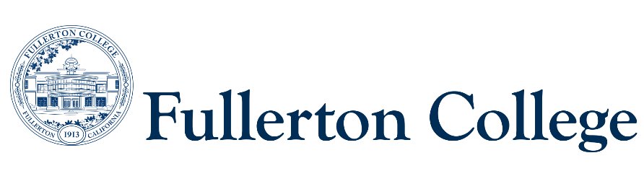

Program Mapping Advisory Taskforce Agenda

February 26, 2024 (1pm-3pm)

Zoom:

<https://fullcoll-edu.zoom.us/j/86704875357?pwd=Z0NmS09NbHA3U0k5SE1BUWJXU3RyQT09>

***Voting Members:***

***Instructional Representative:*** Matt Taylor(F)

***2 Faculty Representatives:*** Joel Salcedo (F)

***2 Counseling Representatives:*** Kaylan Rasch (F), Ana Tovar (F)

***1 Curriculum Committee Representative:*** John Ison (interim)

***2 Associated Student Representatives:*** Ashley Cheng (S)

***Resource Members:***

***Articulation Officer:*** Scott Lee(F)

***VP of Instruction***: José Ramón Núñez (M)

***2 Classified Representatives***: Heather Treminio (C), Bianca Gladen (C)

***Guests:*** Jennifer Merchant

***Recorder:*** Bianca Gladen (C)

***Members Absent:***

**--------------------------------------------------------------------------------------------------------------------------------------------------------------**

C = Classified; F = Faculty, M = Manager, S = Student

**---------------------------------------------------------------------------------------------------------------------------------------------------------------**

1. **Welcome** 
   1. Welcome Ashley Cheng – Associated Student Representative
2. **Approval of Previous Meeting Minutes (November 2023)**
3. **Program Mapper vs. Ed Plan- Marketing Material Language**
   1. Counseling Department’s Statement:
      1. *The Fullerton College degree maps are a great way to preview the path ahead.* *The maps are a general guide to what students can expect to complete in order to earn a certificate or degree from Fullerton College.* *A student education plan (SEP) is a personalized map that is created with a counselor, to achieve a student’s individual goals of certificate/degree attainment, transfer, or both!*
      2. *Degree maps do not take the place of meeting with a counselor for a personalized student education plan. SEPs are developed and tailored to student's needs, with specific courses planned every semester to ensure they meet all their educational and career goals within their planned timeline. It is highly recommended that students meet with a counselor every semester to update and monitor progress towards their SEP completion*
4. **Spring Semester Schedule – Fourth Monday from 1pm-3pm**
   1. February 26
   2. March 25 (Spring Break- No Meeting)
   3. April 22
   4. May 27 (Memorial Day- No Meeting)