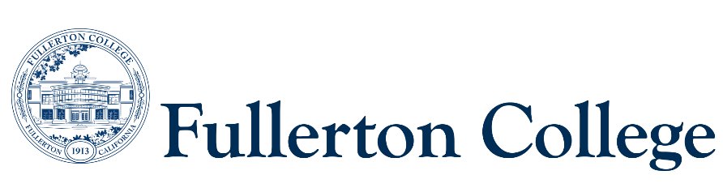

Program Mapping Advisory Taskforce Agenda

February 26, 2024 (1pm-3pm)

Zoom:

<https://fullcoll-edu.zoom.us/j/86704875357?pwd=Z0NmS09NbHA3U0k5SE1BUWJXU3RyQT09>

***Voting Members:***

***Instructional Representative:*** Matt Taylor(F)

***2 Faculty Representatives:*** Joel Salcedo (F)

***2 Counseling Representatives:*** Kaylan Rasch (F), Ana Tovar (F)

***1 Curriculum Committee Representative:*** John Ison (interim)

***2 Associated Student Representatives:*** Ashley Cheng (S)

***Resource Members:***

***Articulation Officer:*** Scott Lee(F)

***VP of Instruction***: José Ramón Núñez (M)

***2 Classified Representatives***: Heather Treminio (C), Bianca Gladen (C)

***Guests:*** Jennifer Merchant

***Recorder:*** Bianca Gladen (C)

***Members Absent:*** José Ramón Núñez

**--------------------------------------------------------------------------------------------------------------------------------------------------------------**

C = Classified; F = Faculty, M = Manager, S = Student

**---------------------------------------------------------------------------------------------------------------------------------------------------------------**

1. **Welcome** 
   1. Welcome Ashley Cheng – Associated Student Representative
   2. John Ison – Curriculum Committee Chair
2. **Approval of Previous Meeting Minutes (November 2023)**
   1. Committee unanimously approved previous meeting minutes
3. **Program Mapper vs. Ed Plan- Marketing Material Language**
   1. Marketing materials have been asked of the Guided Pathways department to use for outreach, counseling, campus communications, etc. We wanted to be clear what the maps are used for vs. what they are not used for. The Guided Pathways office reached out to Counseling department to give an accurate explanation of the difference between pathway maps vs. Student ed plans.
   2. This information will be on FC websites as well as division marketing materials and student facing places where information about Program Mapper lives.
   3. Counseling Department’s Statement:

* + 1. The Fullerton College degree maps are a great way to preview the path ahead. The maps are a general guide to what students can expect to complete in order to earn a certificate or degree from Fullerton College. A student education plan (SEP) is a personalized map that is created with a counselor, to achieve a student’s individual goals of certificate/degree attainment, transfer, or both!
    2. Degree maps do not take the place of meeting with a counselor for a personalized student education plan. SEPs are developed and tailored to student's needs, with specific courses planned every semester to ensure they meet all their educational and career goals within their planned timeline. It is highly recommended that students meet with a counselor every semester to update and monitor progress towards their SEP completion.
  1. The committee motioned to approve the language for marketing materials.

1. **Updates to Curriculum in the Future**
   1. The campus has very clear Design Principles in how we are supposed to map our degrees and certificates. Much of the discussion was based on General Education patterns. In the near future, there will be an update to all our General Education patterns, CalGETC, as well as a revision to the native AA pattern. It is time for the committee to start discussing the new Design Principles for CalGETC. It will not just be GE, it will be when Math and English are taken in program maps, etc.
   2. Once we revise the Design Principles, it will allow us to change the recommendations, for example when to take Math and English.
   3. Where should we start in revising the Design Principles? Should we start at PMAT or start with the general campus?
      1. One of the committee members recommends getting a general sense from initial departments who have already gone through the mapping process by adhering to the Design Principles.
      2. Another committee member mentioned speaking with the ones who were involved in creating the Design Principles and getting their opinion on the revision of the principles.
      3. The committee mentioned possibly creating a small workgroup for the revision. The response to that is that it would be PMAT.
      4. The homework for the PMAT committee will be revising the Design Principles once we consider suggestions from the campus. We ask that the committee look at the current Design Principles and create questions for next meeting based on the current Design Principles that might not make sense.
2. **Spring Semester Schedule – Fourth Monday from 1pm-3pm**
   1. February 26
   2. March 25 (Spring Break- No Meeting)
   3. April 22
   4. May 27 (Memorial Day- No Meeting)