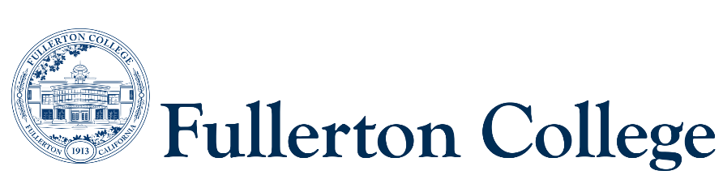

Program Mapping Advisory Taskforce Agenda

November 25, 2024 (1pm-3pm)

Zoom:

<https://fullcoll-edu.zoom.us/j/84189358187?pwd=LdMvbJ2gIE4qffV2x9xzYdT1mK9qa7.1>

***Voting Members:***

***Instructional Representative:*** Jeanne Costello(F)

***2 Faculty Representatives:*** Joel Salcedo (F) Rita Higgins (F)

***2 Counseling Representatives:*** Elisa Latourelle (F), Ana Tovar (F)

***1 Curriculum Committee Representative:*** John Ison (F)

***2 Associated Student Representatives:*** Ashley Cheng (S)

***Resource Members:***

***Articulation Officer:*** Scott Lee (F)

***VP of Instruction***: José Ramón Núñez (M)

***2 Classified Representatives***:

***Guests:*** Jennifer Merchant (M)

***Recorder:*** Bianca Gladen (C)

***Members Absent:***

**----------------------------------------------------------------------------------------------------------------------------------------**

C = Classified; F = Faculty, M = Manager, S = Student

**---------------------------------------------------------------------------------------------------------------------------------------**

1. **Welcome**
2. **Approval of Previous Meeting Minutes**
3. **AA/AS Revision of Design Principles**
   1. [AA/AS Revision of Design Principles](https://fullcolledu.sharepoint.com/:x:/s/GuidedPathways/EVw01VYhJWVAjuIzZVVBqoUBjC-6coXtGTIRV2Vrxo7BTA?e=VxaWXN) (in red)
4. **Which map should be the Default map?**
   1. In Program Mapper, we have the ability to set a default map. A default map is the first map students see when clicking on a program.
      1. 2 year vs. 3 year maps
      2. AA/AS vs. CalGETC maps
5. **Discuss Sustainable Program Mapping Review Process**
   1. What constitutes a sustainable process?
   2. How to institutionalize this process into our day-to-day duties
6. **Operationalizing Program Mapper**
   1. Ideas for use of the $60k grant
      1. Hiring a PE to help update the maps
      2. Marketing the maps (program videos)
      3. Market towards specific populations
         1. Student Focus Groups
7. **CSUF 2+2 Meeting Recap**
   1. On October 30th, Dr. Merri Lynn Casem, VP of General Education met with the Guided Pathways team to discuss next steps of the 2+2 project.
8. **Suggestions for next month’s agenda**