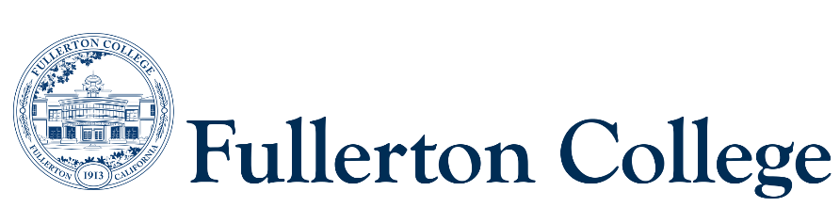

Program Mapping Advisory Taskforce Agenda

April 28, 2025 (1pm-3pm)

Zoom:

<https://fullcoll-edu.zoom.us/j/87370152913?pwd=jreTxmBkPbVQAnx38UbaR44FzhYHNl.1>

***Voting Members:***

***Instructional Representative:*** Jeanne Costello(F)

***2 Faculty Representatives:*** Joel Salcedo (F) Rita Higgins (F)

***2 Counseling Representatives:*** Elisa Latourelle (F), Ana Tovar (F)

***1 Curriculum Committee Representative:*** John Ison (F)

***2 Associated Student Representatives:*** Ashley Cheng (S)

***Resource Members:***

***Guided Pathways Director:*** Jennifer Merchant (M)

***Articulation Officer:*** Scott Lee (F)

***VP of Instruction***: José Ramón Núñez (M)

***2 Classified Representatives***: Bianca Gladen (C)

***Guests:***

***Recorder:*** Bianca Gladen (C)

***Members Absent:***

**----------------------------------------------------------------------------------------------------------------------------------------**

C = Classified; F = Faculty, M = Manager, S = Student

**---------------------------------------------------------------------------------------------------------------------------------------**

1. **Welcome**
2. **Approval of Previous Meeting Notes**
3. **Exception to the Design Principles ADT Maps**
   1. Spanish ADT – Klaus Hornell
      1. The Spanish ADT program would like to have two different maps, one map for native speakers (SPAN 201 F) and another map for non-native speakers ([SPAN 203 F)](https://catalog.nocccd.edu/search/?P=SPAN%20203%20F). Having two different maps would split up the “SPAN 201 F or SPAN 203 F” courses shown in the catalog.
   2. Music ADT – Nicola Dedmon
      1. Would like to add a corequisite course MUSA 202 F to be offered alongside MUSA 200 F
   3. Political Science ADT – Jodi Balma (2:50pm)
      1. Would like to create a UC map and choose a general ed math course- MATH 120 F
4. **Fall 2025 Local AA Revision Process**
5. **Approval Process – Linking maps with CSUF**
6. **New Programs – Hornet Pathway Placement** (possible placement in italics)
   1. Computer Aided Manufacturing (CAM) Certificate (*Applied Technology, Engineering, & Math)*
   2. Criminal Law Specialty Certificate *(Public Service & Education)*
   3. Directing for Theatre, Film, and Television Certificate (*Visual & Performing Arts, & Design)*
   4. eDiscovery and Technology Specialty Certificate (*Applied Technology, Engineering, & Math)*
   5. Fashion Stylist Certificate (*Visual & Performing Arts, & Design)*
   6. Law School First Year Prep Specialty Certificate *(Public Service & Education)*
   7. Mastercam Certificate (*Applied Technology, Engineering, & Math)*
   8. Meteorology Associate in Science Degree *(Science, Health, & Wellness)*
   9. Mindfulness Certificate *(Science, Health, & Wellness)*
   10. Oceanography Associate in Science Degree *(Science, Health, & Wellness)*
   11. Real Estate Law Specialty Certificate (*Business)*
   12. Sports Nutrition Certificate *(Science, Health, & Wellness)*
7. **CSUF Meeting Update**
   1. We discussed linking programs from Fullerton College that do not have a direct transfer pathway at CSUF.
      1. Human Services CSUF Degree Example: A solution we discussed was linking a closely related program, like Sociology and Psychology. We could create a second Sociology or Psychology map that is tailored to the Human Services degree at CSUF.
   2. Guided Pathways will be scheduling a meeting with Sociology and Psychology to discuss linking maps with Human Services
   3. Once PMAT decides on an approval process to link maps, we will meet with CSUF again to discuss next steps.