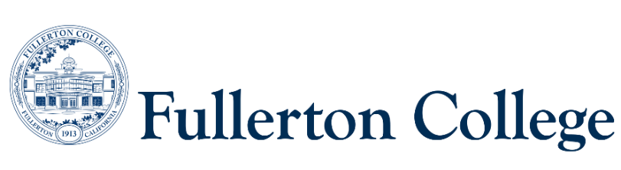
Program Mapping Advisory Taskforce Agenda
February 23, 2026 (1pm-3pm)
Zoom:
https://fullcoll-edu.zoom.us/j/83321707460?pwd=Bi2ZY8Ns3nFAUbAi6lDtAeCTtIiOHf.1

Voting Members:
Guided Pathways Faculty Coordinator, Committee Chair: Jeanne Costello(F)
2 Faculty Representatives: Alissa Matus (F), Kim Vandervort (F)
2 Counseling Representatives: Elisa Latourelle (F), Ana Tovar (F)
1 Curriculum Committee Representative: John Ison (F)
2 Associated Student Representatives: (none)
Resource Members:
Guided Pathways Director: Jennifer Merchant (M)
Articulation Officer: Scott Lee (F)
VP of Instruction: José Ramón Núñez (M)
2 Classified Representatives: Bianca Gladen (C), Heather Treminio (C)

Guests: Magaly Agredano (Guided Pathways Special Projects Coordinator)
Recorder: Rebekah Lee (C)

----------------------------------------------------------------------------------------------------------------------------------------
C = Classified; F = Faculty, M = Manager, S = Student
---------------------------------------------------------------------------------------------------------------------------------------

- Welcome
- Approval of Previous Meeting Notes
- Curriculum Updates (John)
- Program Mapping Update (Magaly)
  - Fall/Spring Program Mapping progress
    - Number of programs mapped Fall semester (54)
    - Plans for Spring Semester (40 more to go)
  - Program Pathways Mapper 2.0 update
    - “go live” meeting upcoming
    - Publication priorities
- Milestone Tile Ideas
  - Shall we use these to indicate a map is under construction?
  - If so, what should the tile say?
- Ideas for Additional Future Maps
  - CSUF-specific (per Aspen Institute discussions)
  - HBCU Transfer
  - ZTC Program Pathways
- Aspen Transfer Institute Updates (Jeanne)
  - Linking maps with CSUF Road maps
  - Faculty Convening ideas/timeline
- Program Mapper and Students
  - On-campus Outreach Events
  - HS Outreach videos [using special funds for this purpose] (Magaly)
  - Dual Enrollment (discussion pending for rollout in Fall)
  - AS (discussion pending; waiting for 2.0 to go live)
9) Program Placement
a. Aging Studies AA
b. CalGETC certificate (what do we do with these?)
c. INDS in Arts and Human Expression – move to different pathway

