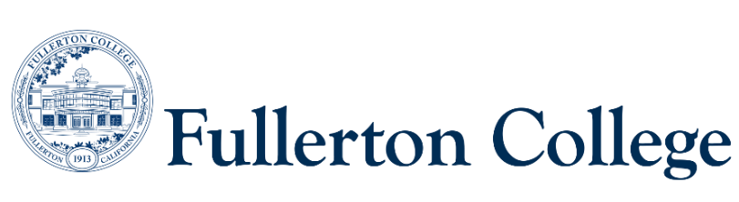
Program Mapping Advisory Taskforce Agenda
August 24, 2026 (1pm-3pm)
Zoom:
https://fullcoll-edu.zoom.us/j/83321707460?pwd=Bi2ZY8Ns3nFAUbAi6lDtAeCTtIiOHf.1

Voting Members:
Guided Pathways Faculty Coordinator, Committee Chair: Ron Farol (F)
2 Faculty Representatives: Alissa Matus (F), Kim Vandervort (F)
2 Counseling Representatives: Dr. Porsha Boyd (F), Ana Tovar (F)
1 Curriculum Committee Representative: John Ison (F)
2 Associated Student Representatives: (none)
Resource Members:
Guided Pathways Director: Jennifer Merchant (M)
Articulation Officer: Scott Lee (F)
VP of Instruction: Dr. Carlos Ayon (M)
2 Classified Representatives: Bianca Gladen (C), Rebekah Lee (C)

Guests: Magaly Agredano (Guided Pathways Special Projects Coordinator)
Recorder: Rebekah Lee (C)

----------------------------------------------------------------------------------------------------------------------------------
C = Classified; F = Faculty, M = Manager, S = Student
----------------------------------------------------------------------------------------------------------------------------------

- Welcome
- Approval of Previous Meeting Notes
- Committee Membership/Meeting Updates
  - Welcome Dr. Porsha Boyd!!
  - Welcome Dr. Carlos Ayon!!
  - Welcome, Ron Farol!! He was elected Guided Pathways Faculty Coordinator and will chair PMAT for 26/27
- Curriculum Updates (John)
- Certificate and Milestones (Jenn and Magaly)
  - Dean’s Council Presentation (Jenn and Magaly)
    - Update email information
    - Certificate Milestone Templates
- Program Mapping Update
  - Program Pathways Mapper updates (Magaly)
  - PPM Video progress (Jenn)
- Discuss tile language for INDS degrees
- Milestone/Reminder Tile Ideas
  - CSUF Transfer Milestone
  - Applying for course substitutions
- Program Placement
  - Artificial Intelligence Foundations Certificate (Applied Technology, Engineering, and Mathematics, ATEM)
  - Musical Theatre Level II Certificate (Visual and Performing Arts and Design, VPAD)
10) Fall Priorities
  - Spreadsheet for updating information with dept. Coordinators about F/S offerings (Magaly)
  - Student Outreach and Promotion (Ron and Jenn)
    - Work with Joel Salcedo and AS to bring Program Mapper to students
    - Dual Enrollment

